MAN SHOT IN THE HEAD FINDS OUT 5 YEARS LATER
A Polish man living in Germany went about his business for about five years without noticing he had been shot in the head because he was drunk when it happened. Police in the western city of Bochum said on Tuesday doctors found a .22 caliber bullet in the back of his head after the 35-year-old went to have what he thought was a cyst removed.

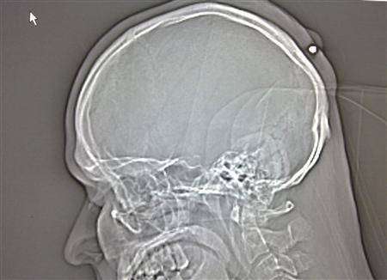

CAT PREDICTS DEATH
Oscar the cat lives at a nursing and rehabilitation center in Providence, R.I. He roams the halls, is generally unsociable, and spends little time with anyone who has more than a few hours to live. He rarely errs in his predictions and this year extended his predicting streak to 50. He senses death and cuddles with the elderly patients until they pass.

